**Algorithm Analysis**

**Exercises 1:**

**Determine Θ for the following code fragment in the average case. Assume that all variables are of type "int".**

sum = 0;

for (i = 1; i ≤ n; i *= 2)

for (j = 1; j ≤ n; j++)

sum++;

**Exercise 2:**

1. Give an analysis of the running time (Big-Oh notation) for each of the following 4 program fragments. Note that the running time corresponds here to the number of times the operation sum++ is executed. sqrt is the function that returns the square root of a given number.

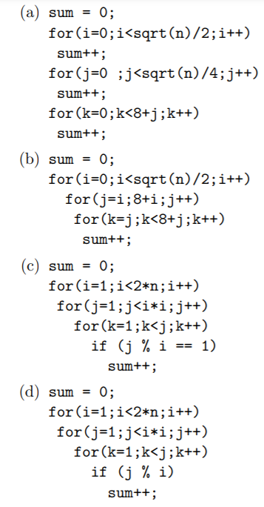

1. If it takes 10ms to run program (b) for n=100, how long will it take to run for n=400 ?
2. If it takes 10ms to run program (a) for n=100, how large a problem can be solved in 40ms ?

**Exercise 3:**

**Find the complexity of the below program:**

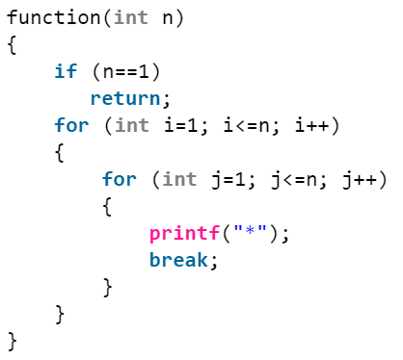

**Exercise 4:**

**Find the complexity of the below program:**

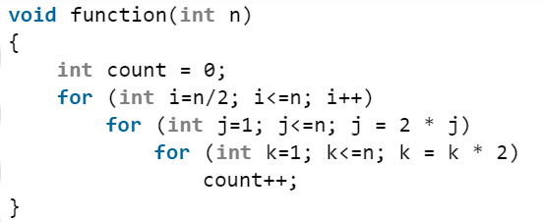

**Exercise 5:**

**Find the complexity of the below program:**

